**AMERICAN INTERNATIONAL UNIVERSITY- BANGLADESH**

Course: Introduction to Database

Section: H

Course Instructor: Rifat Tasnim Anannya

Project Name: Travel Agency Database Management System

Date of Submission: 11 December 2019

|  |  |
| --- | --- |
| NAME | ID |
| 1. ATIQULLAH HABIB | 19-40022-1 |
| 1. ANINDITA ROY | 19-40001-1 |
| 1. MD MUSFIQUR RAHMAN | 19-40008-1 |
| 1. MOHAMMAD NAHIAN BIN EUSUF | 18-39216-3 |

|  |  |  |
| --- | --- | --- |
| Name: ATIQULLAH HABIB | ID: 19-40022-1 | Sec: H |

CO1: Solve problems of Relational Algebra to interpret complex engineering problems

|  |  |  |  |  |
| --- | --- | --- | --- | --- |
| Category | Inadequate (1) | Satisfactory(2) | Good(3-4) | Excellent(5) |
| Syntax |  |  |  |  |
| Correctness |  |  |  |  |
| Standard |  |  |  |  |

CO2: Design ER Diagram to solve complex engineering problems

|  |  |  |  |  |
| --- | --- | --- | --- | --- |
| Category | Inadequate (1) | Satisfactory(2) | Good(3-4) | Excellent(5) |
| Syntax |  |  |  |  |
| Correctness |  |  |  |  |
| Standard |  |  |  |  |

CO3: Demonstrate DDL, DML and SQL using Oracle

|  |  |  |  |  |
| --- | --- | --- | --- | --- |
| Category | Inadequate (1) | Satisfactory(2) | Good(3-4) | Excellent(5) |
| Syntax |  |  |  |  |
| Correctness |  |  |  |  |
| Standard |  |  |  |  |

|  |  |  |
| --- | --- | --- |
| Name: ANINDITA ROY | ID: 19-40001-1 | Sec: H |

CO1: Solve problems of Relational Algebra to interpret complex engineering problems

|  |  |  |  |  |
| --- | --- | --- | --- | --- |
| Category | Inadequate (1) | Satisfactory(2) | Good(3-4) | Excellent(5) |
| Syntax |  |  |  |  |
| Correctness |  |  |  |  |
| Standard |  |  |  |  |

CO2: Design ER Diagram to solve complex engineering problems

|  |  |  |  |  |
| --- | --- | --- | --- | --- |
| Category | Inadequate (1) | Satisfactory(2) | Good(3-4) | Excellent(5) |
| Syntax |  |  |  |  |
| Correctness |  |  |  |  |
| Standard |  |  |  |  |

CO3: Demonstrate DDL, DML and SQL using Oracle

|  |  |  |  |  |
| --- | --- | --- | --- | --- |
| Category | Inadequate (1) | Satisfactory(2) | Good(3-4) | Excellent(5) |
| Syntax |  |  |  |  |
| Correctness |  |  |  |  |
| Standard |  |  |  |  |

|  |  |  |
| --- | --- | --- |
| Name: MD MUSFIQUR RAHMAN | ID: 19-40008-1 | Sec: H |

CO1: Solve problems of Relational Algebra to interpret complex engineering problems

|  |  |  |  |  |
| --- | --- | --- | --- | --- |
| Category | Inadequate (1) | Satisfactory(2) | Good(3-4) | Excellent(5) |
| Syntax |  |  |  |  |
| Correctness |  |  |  |  |
| Standard |  |  |  |  |

CO2: Design ER Diagram to solve complex engineering problems

|  |  |  |  |  |
| --- | --- | --- | --- | --- |
| Category | Inadequate (1) | Satisfactory(2) | Good(3-4) | Excellent(5) |
| Syntax |  |  |  |  |
| Correctness |  |  |  |  |
| Standard |  |  |  |  |

CO3: Demonstrate DDL, DML and SQL using Oracle

|  |  |  |  |  |
| --- | --- | --- | --- | --- |
| Category | Inadequate (1) | Satisfactory(2) | Good(3-4) | Excellent(5) |
| Syntax |  |  |  |  |
| Correctness |  |  |  |  |
| Standard |  |  |  |  |

|  |  |  |
| --- | --- | --- |
| Name: MOHAMMAD NAHIAN BIN EUSUF | ID: 18-39216-3 | Sec: H |

CO1: Solve problems of Relational Algebra to interpret complex engineering problems

|  |  |  |  |  |
| --- | --- | --- | --- | --- |
| Category | Inadequate (1) | Satisfactory(2) | Good(3-4) | Excellent(5) |
| Syntax |  |  |  |  |
| Correctness |  |  |  |  |
| Standard |  |  |  |  |

CO2: Design ER Diagram to solve complex engineering problems

|  |  |  |  |  |
| --- | --- | --- | --- | --- |
| Category | Inadequate (1) | Satisfactory(2) | Good(3-4) | Excellent(5) |
| Syntax |  |  |  |  |
| Correctness |  |  |  |  |
| Standard |  |  |  |  |

CO3: Demonstrate DDL, DML and SQL using Oracle

|  |  |  |  |  |
| --- | --- | --- | --- | --- |
| Category | Inadequate (1) | Satisfactory(2) | Good(3-4) | Excellent(5) |
| Syntax |  |  |  |  |
| Correctness |  |  |  |  |
| Standard |  |  |  |  |

MENU

TOPIC

1. Introduction
2. ER Diagram
3. Normalization
4. DDL & DML
5. Constraint
6. Sequence
7. Query Question
8. Relational Algebra

**Introduction**

Travel agency is identified by t_id, and its name, age, address, contact, email, salary must be recorded. And a travel agency has at least one client. Travel agency has many contact and email.

Clients are identified by c_id. For each client, the name, age, address, contact and email must be recorded. Client has many contact and email.

package is identified by p_id and name, type, person, price, details must be recorded. Travel agency manages several packages and several clients choose one package for them.

Each Hotel has a h_id, name, phone, Email, rent. Package is including Hotel.

For ticket tk_id, type, company, aperture, departure, price, counter and destination must be recorded. And package contains several types of tickets.

**ER Diagram**

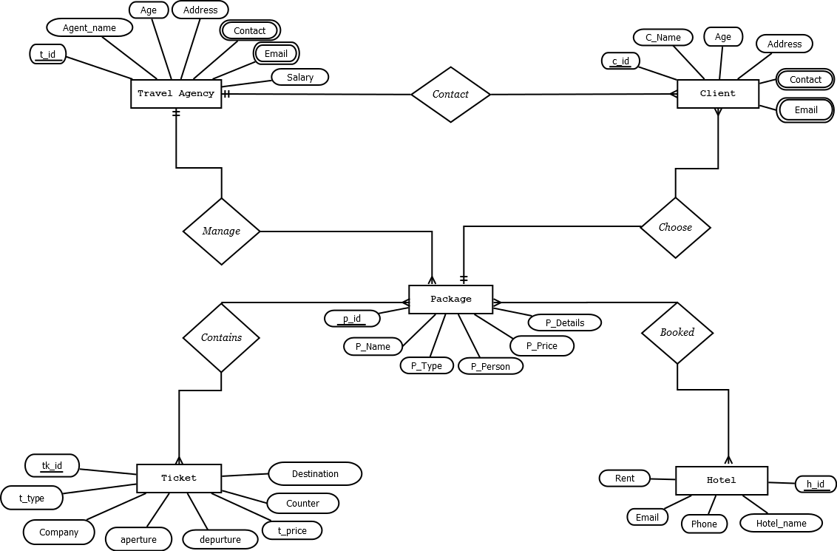

**Normalization**

Contact: (T_id, agent_name, age, address, contact, email, job, salary, C_id, c_name, age, address, contact, email)

1NF → TRAVEL_AGENCY

CLIENT

2NF → T_id, agent_name, age, address, contact, email, job, salary

C_id, c_name, age, address, contact, email

3NF → No transitive dependency.

Table list for contact:

1. T_id, agent_name, age, address, salary

2. T_id, contact→ composite primary key

3. T_id, email→ composite primary key

4. C_id, c_name, age, address, T_id, P_id

5. C_id, contact→ composite primary key

6. C_id, email→ composite primary key

Manage: (T_id, agent_name, age, address, contact, email, job, salary, P_id, p_name, p_type, p_person, p_price, p_details)

1NF→ Contact is a multivalued attribute

Email is a multivalued attribute

2NF→ T_id, agent_name, age, address, contact, email, job, salary

P_id, p_name, p_type, p_person, p_price, p_details

3NF→ T_id, agent_name, age, address, contact, email

P_id, p_name

P2_id, p_type, p_person, p_price, p_details

Table list from manage:

7. T_id, agent_name, age, address, job, salary

8. T_id, contact→ composite primary key

9. T_id, email→ composite primary key

10. P_id, p_name, P2_id, T-id

11. P2_id, p_type, p_person, p_price, p_details

Choose: (C_id, c_name, age, address, contact, email, P_id, p_name, p_type, p_person, p_price, p_details)

1NF→ Contact is a multivalued attribute.

Email is a multivalued attribute.

2NF→ C_id, c_name, age, address, contact, email

P_id, p_name, p_type, p_person, p_price, p_details

3NF→ C_id, C_name, age, address, contact, email

P_id, p_name

Ps_id, p_type, p_person, p_price, p_details

Table list from choose:

12. C_id, C_name, age, address, P_id

13. C_id, contact→ composite primary key

14. C_id, email→ composite primary key

15. P_id, p_name, P2-id

16. P2_id, p_type, p_person, p_price, p_details

Contains: (P_id, p_name, p_type, p_person, p_price, p_details, TK_id, t_type, company, aperture, departure, t_price, counter, destination)

1NF→ No multivalued attribute

2NF→ P_id, p_name, p_type, p_person, p_price, p_details

TK_id, t_type, company, aperture, departure, t_price, counter, destination

3NF→ P_id, p_name

p2_id, p_type, p_person, p_price, p_details

TK_id, company, aperture, departure, t_type, t_price, counter, destination

Table list from contains:

17. P_id, p_name, p_details, P2_id

18. P2_id, p_type, p_person, p_price, p_details

19. TK_id, company, aperture, departure, t_type, t_price, counter, destination

20. N1_id, P_id, tk_id

Booked: (P_id, p_name, p_person, p_price, p_details, H_id, hotel_name, phone, email, rent)

1NF→ No multivalued attribute.

2NF→ P_id, p_name, p_type, p_person, p_price, p_details

H_id, hotel_name, phone, email, rent

3NF→ P_id, p_name

P2_id, P_type, p_person, p_price, p_details

H_id, hotel_name, phone, email, rent

Table list from booked:

21. P_id, p_name, P2_id

22. P2_id, p_type, p_person, p_price, p_details

23. H_id, hotel_name, phone, email, rent

24. N2_id, P_id, H_id

|  |  |  |
| --- | --- | --- |
| Table number | Table name | Column |
| 01 | TRAVEL_ANGENCY | T-id, agent_name, age, address, job, salary |
| 02 | TA_CONTACT | T_id, contact→ composite primary key |
| 03 | TA_EMAIL | T_id, email→ composite primary key |
| 04 | CLIENT | C_id, c_name, age, address, T_id, P_id |
| 05 | C_CONTACT | C_id, contact→ composite primary key |
| 06 | C_EMAIL | C_id, email→ composite primary key |
| 07 | PACKAGE | P_id, p_name, P2_id, T_id |
| 08 | PACKAGE _2 | P2_id, P_type, p_person, p_price, p_details |
| 09 | TICKET | TK_id,company,aperture,departure,t_type,t_price,counter,destination |
| 10 | NEW_TABLE_1 | N1_id, P_id, TK_id |
| 11 | HOTEL | H_id, hotel_name, phone, email, rent |
| 12 | NEW_TABLE_2 | N2_id, P_id, H_id |

Final table list:

**DDL & DML**

TRAVEL_AGENCY:

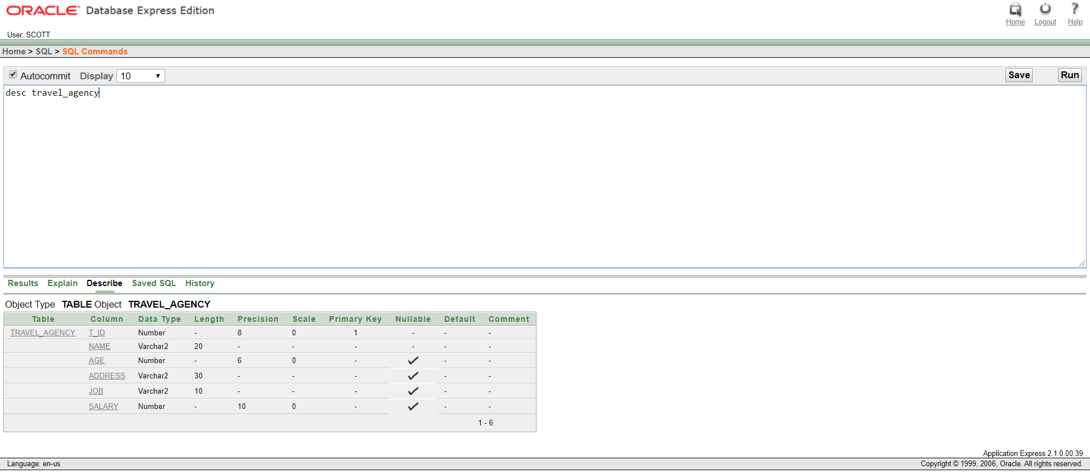

Description of TRAVEL_AGENCY

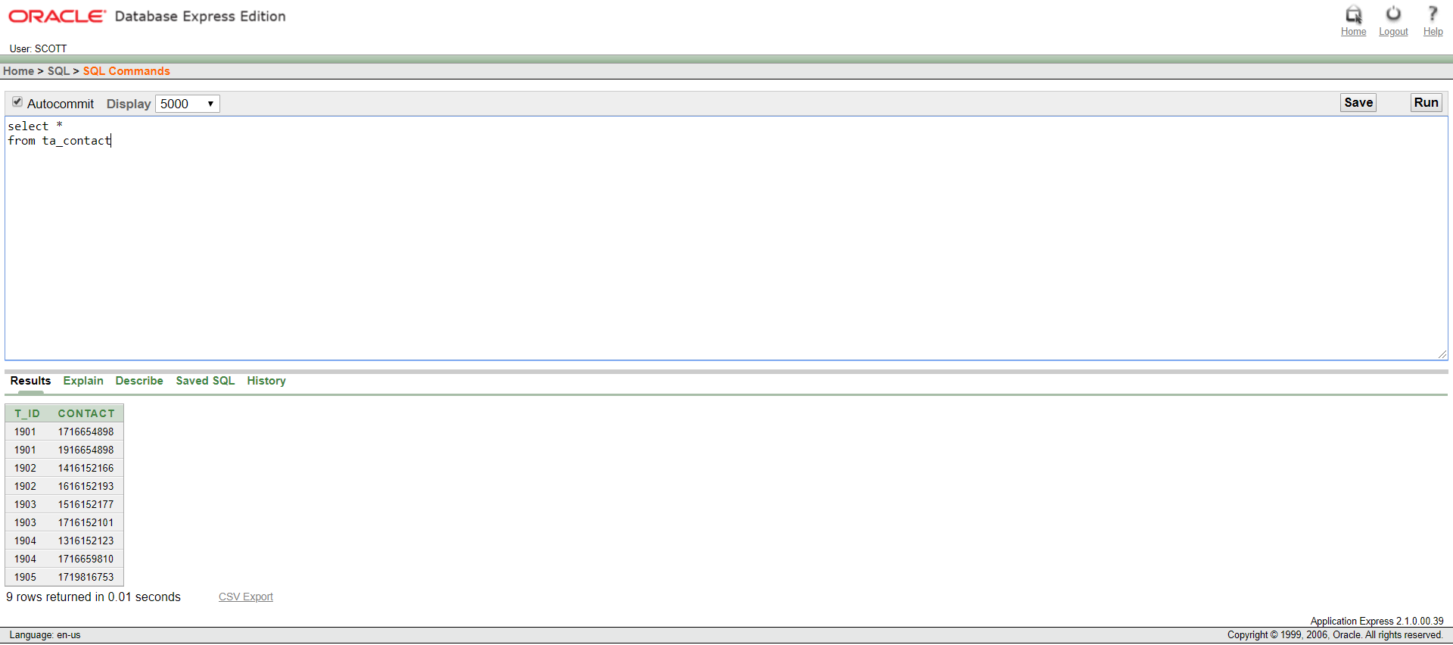

Description of TA_CONTACT

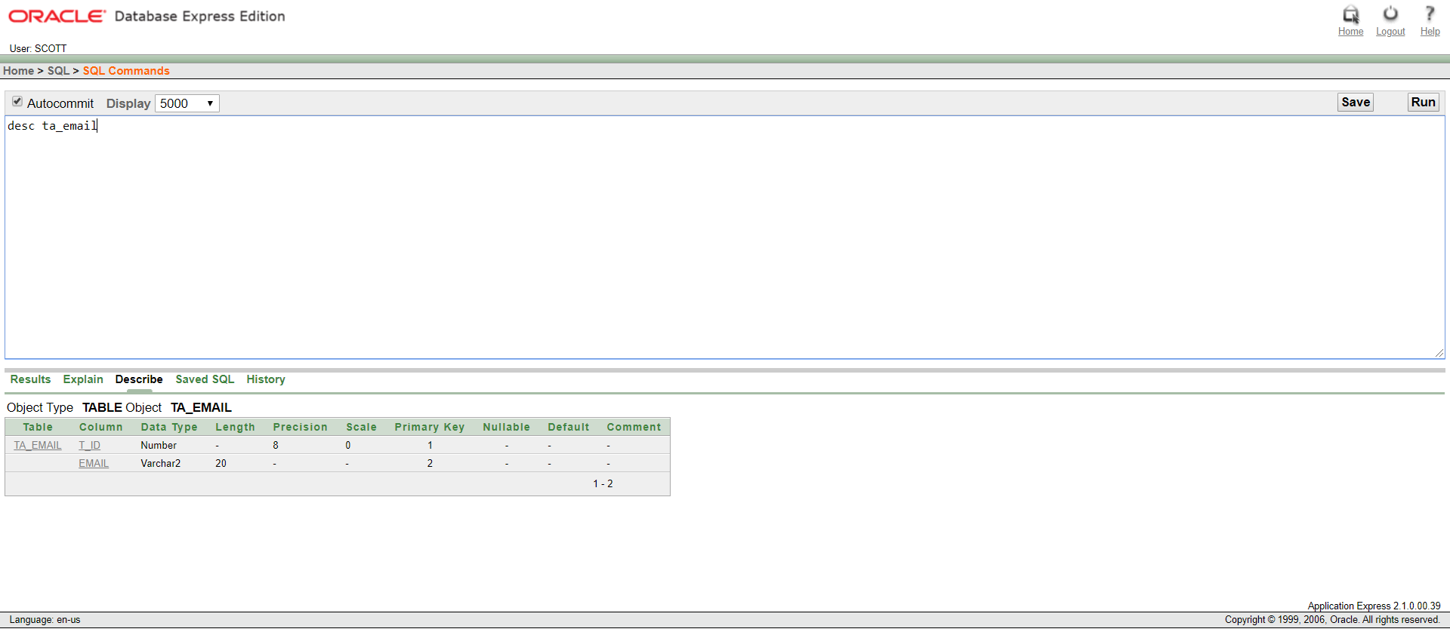

Description of TA_EMAIL

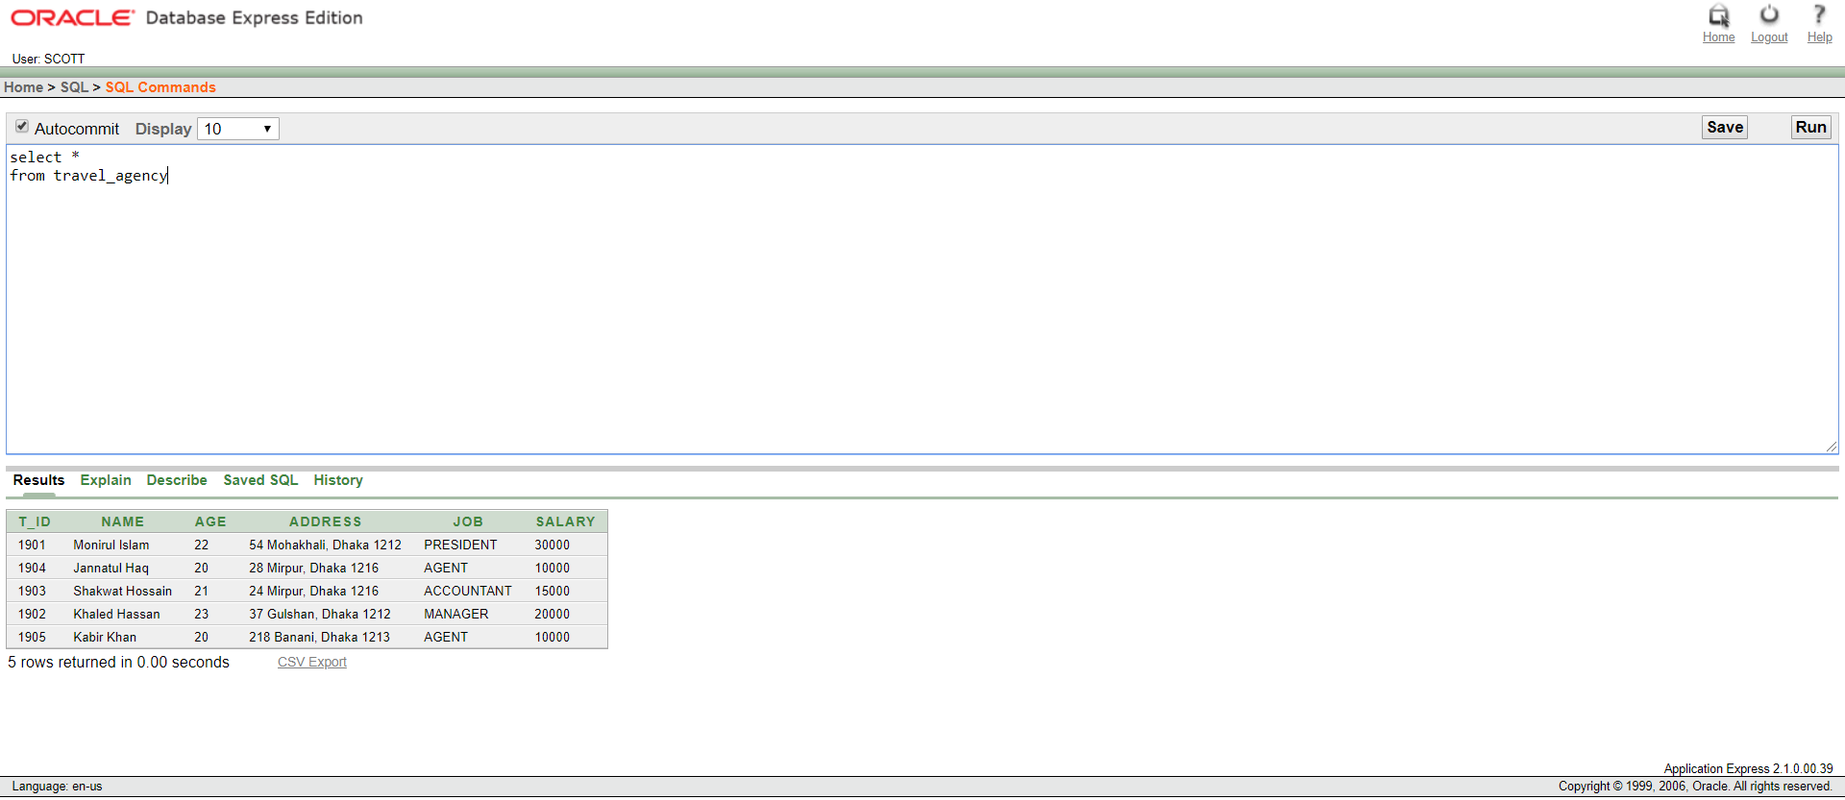

Table: TRAVEL_AGENCY



Table: TA_CONTACT

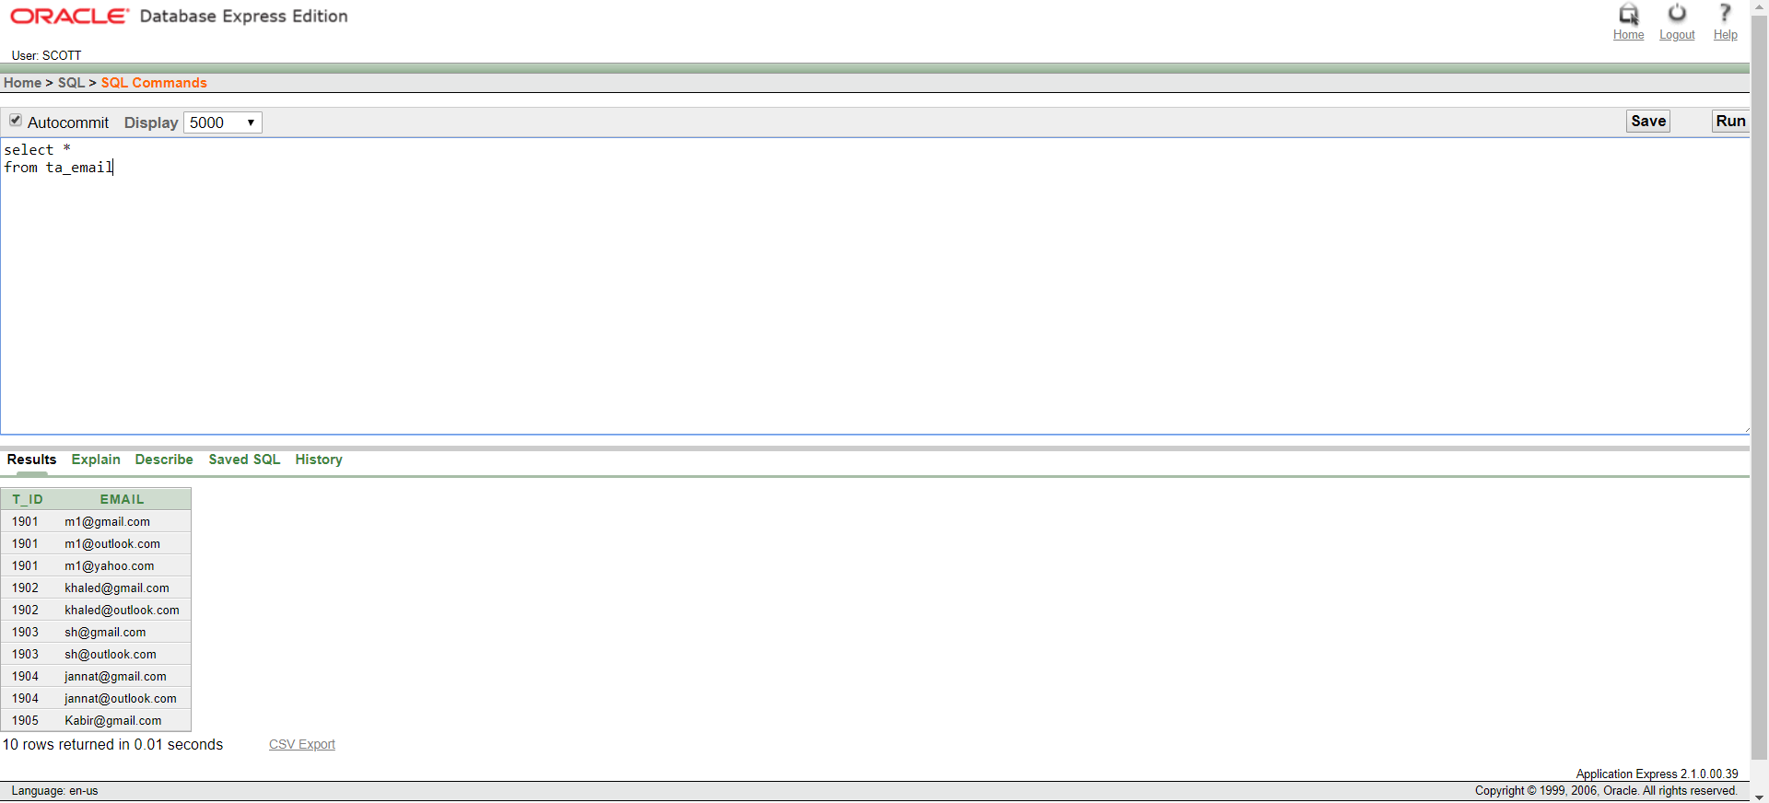

Table: TA_EMAIL

CLIENT:

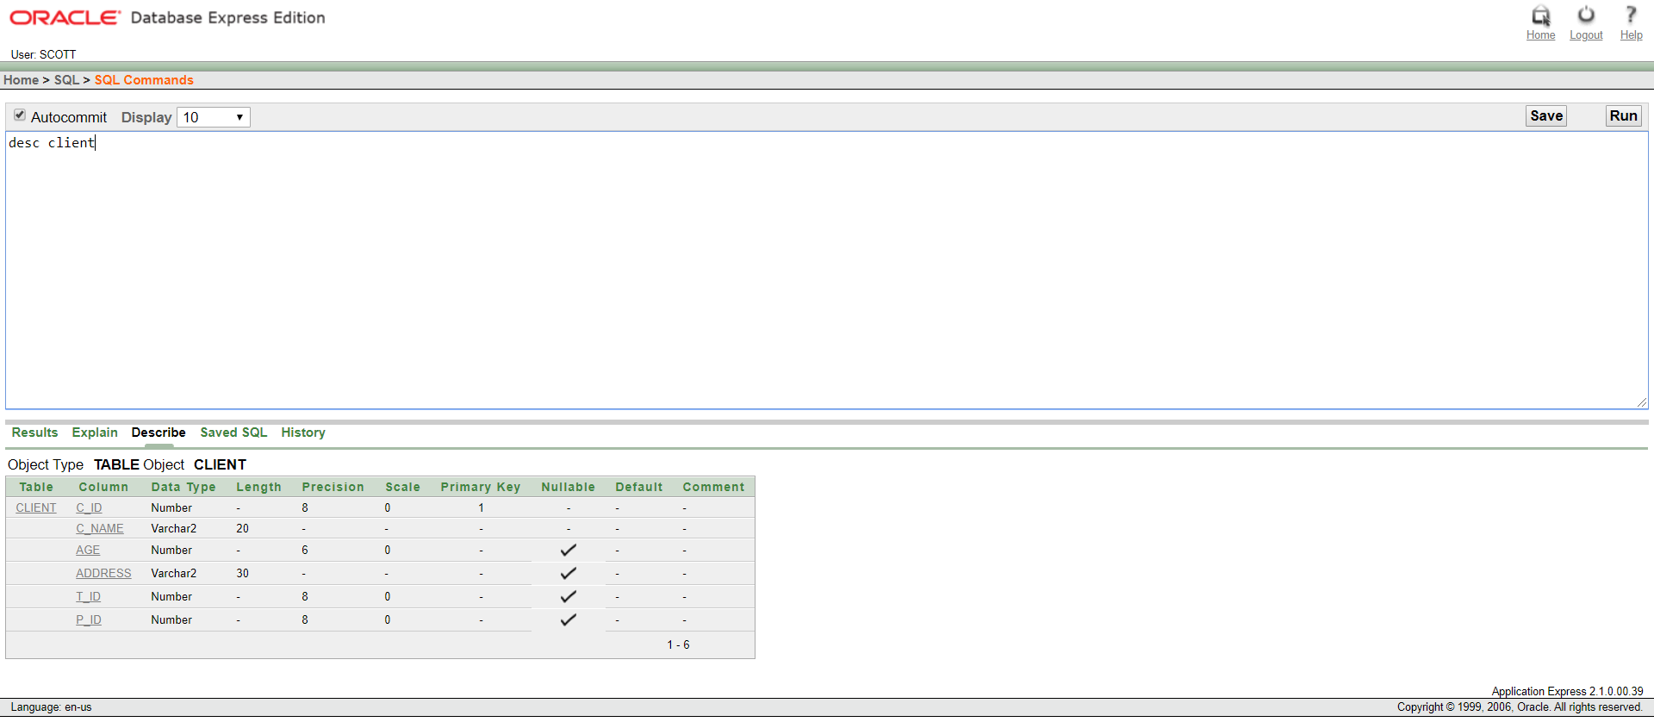

Description of CLIENT

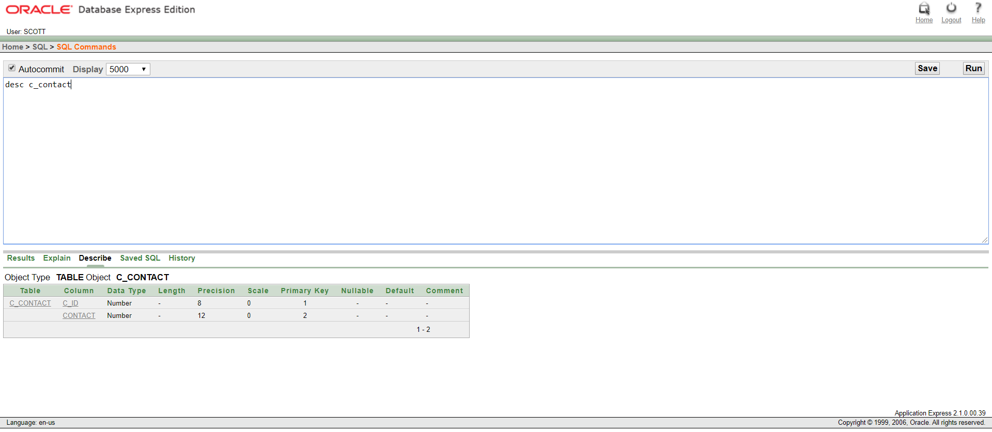

Description of C_CONTACT

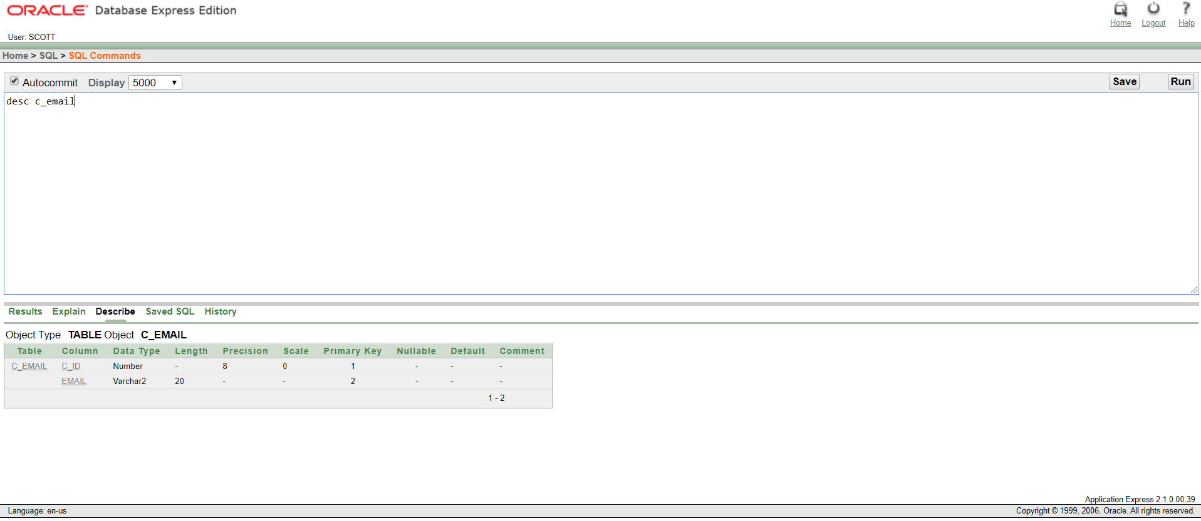

Description of C_EMAIL

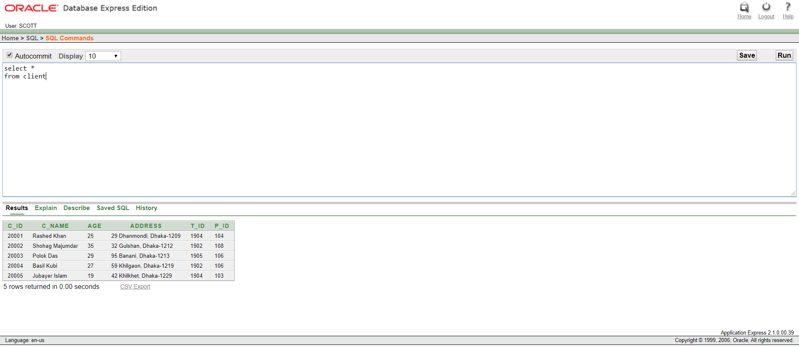

Table: CLIENT

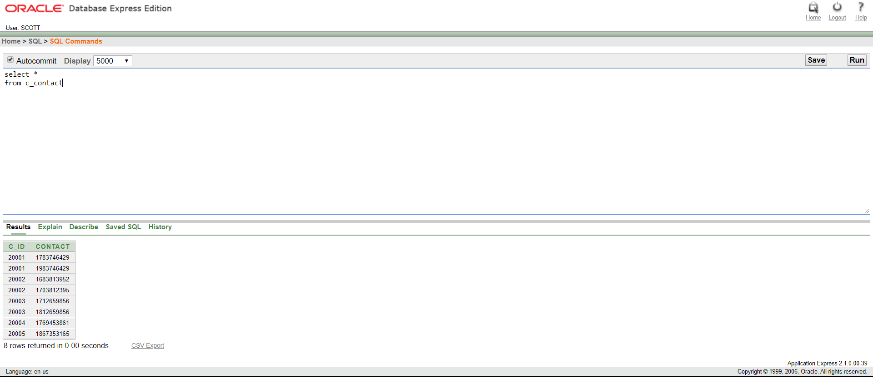

Table: C_CONTACT

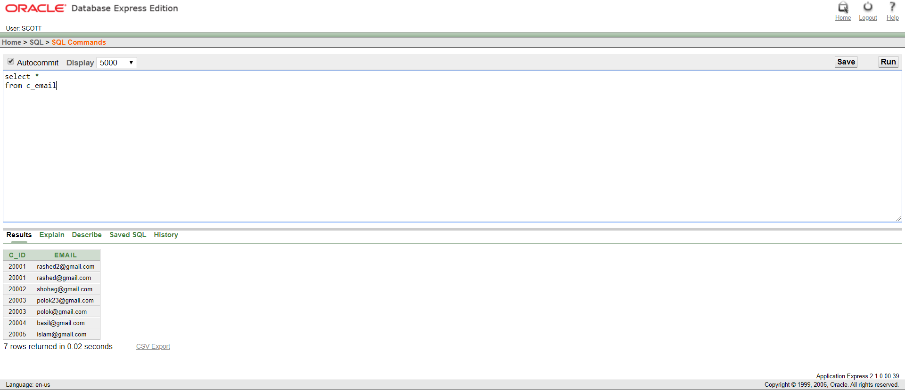

Table: C_EMAIL

PACKAGE:

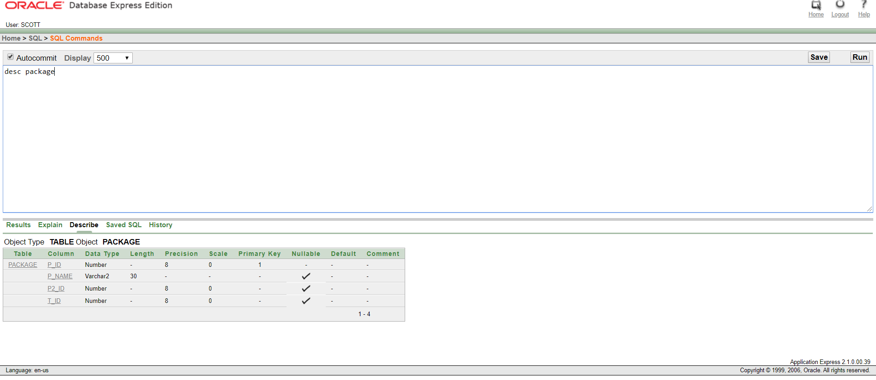

Description of PACKAGE

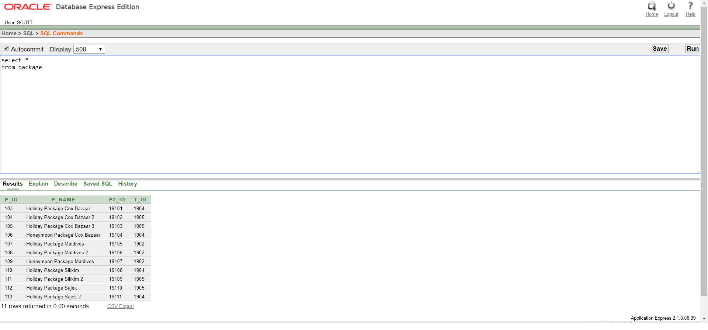

Table: PACKAGE

PACKAGE_2:

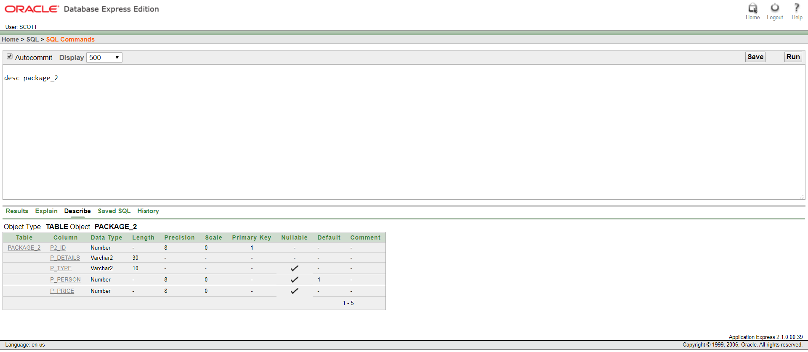

Description of PACKAGE_2

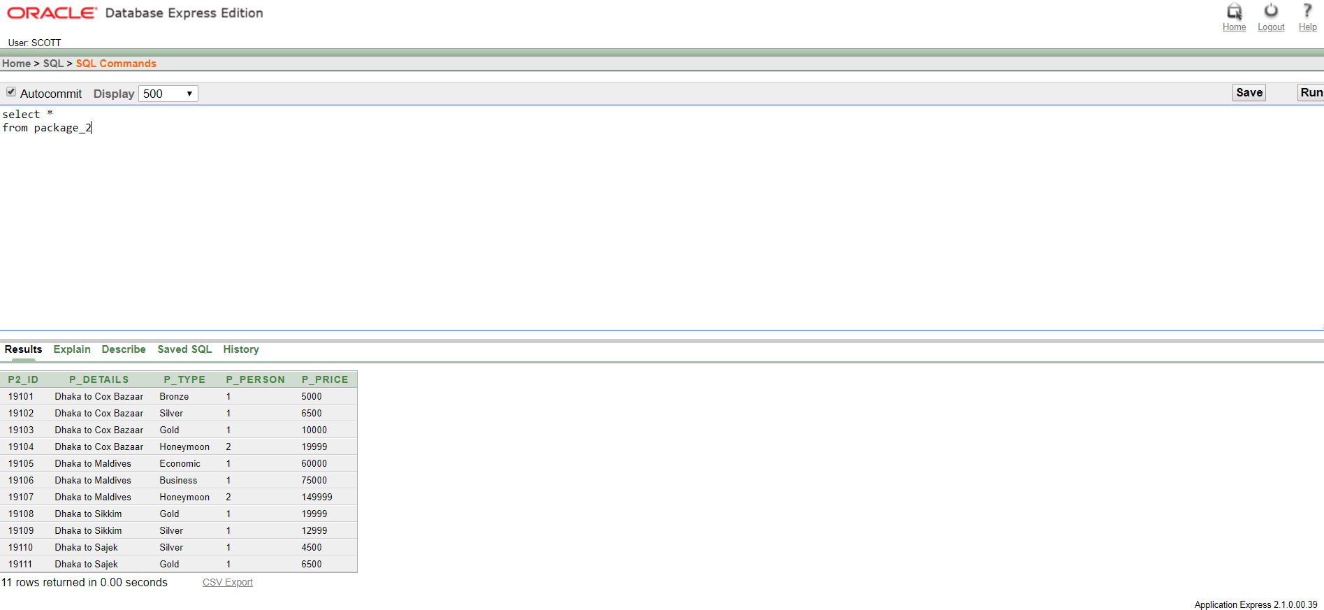

Table: PACKAGE_2

TICKET:

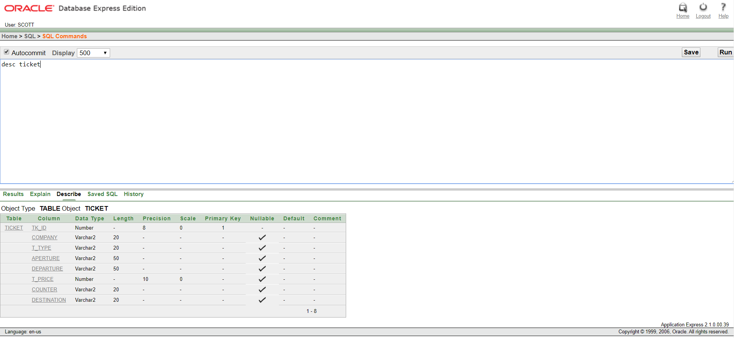

Description of TICKET

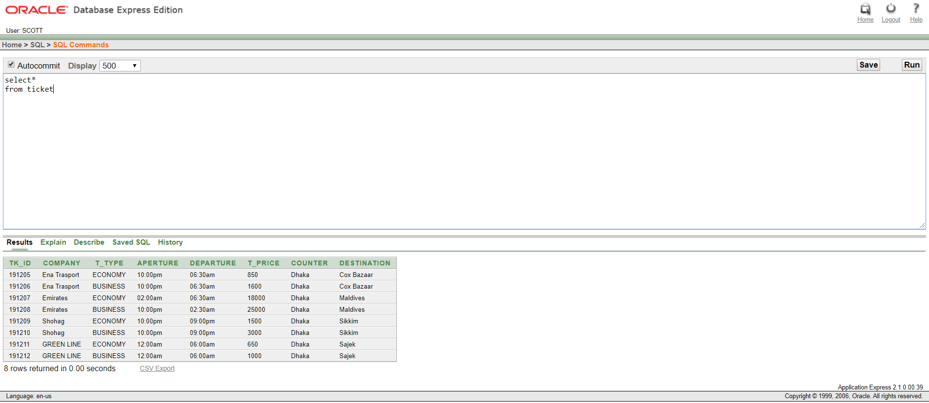

Table: TICKET

NEW_TABLE_1:

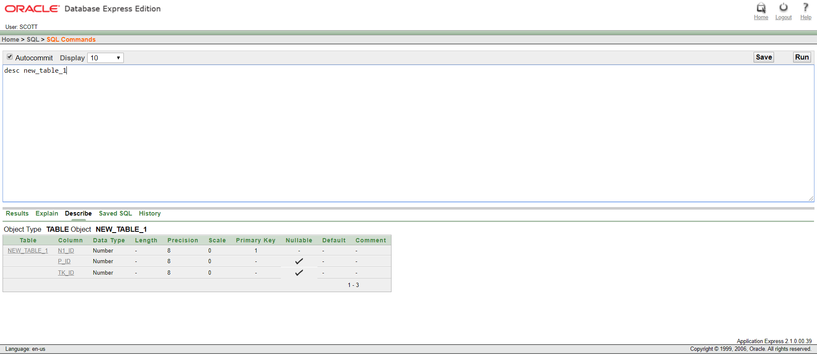

Description of NEW_TABLE_1

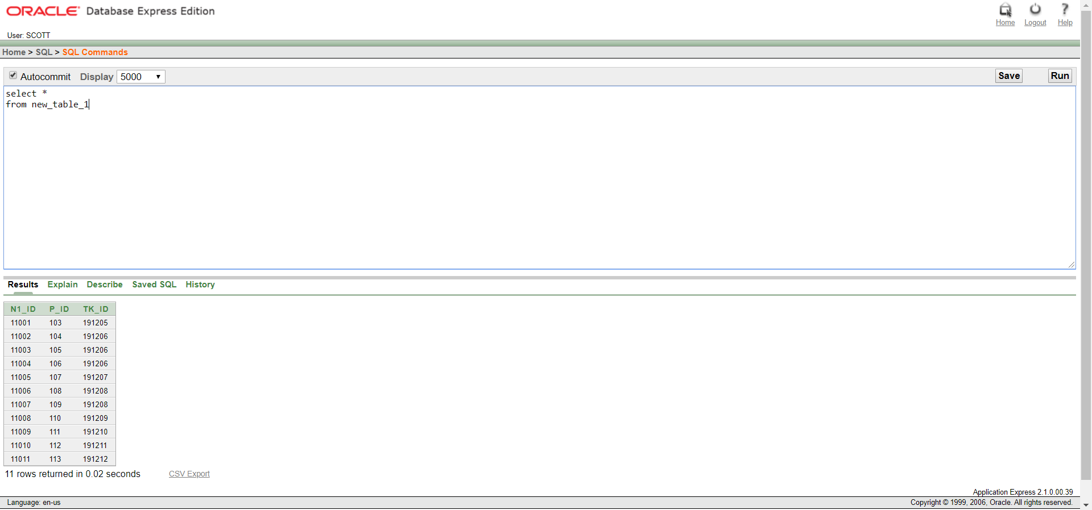

Table: NEW_TABLE_1

HOTEL:

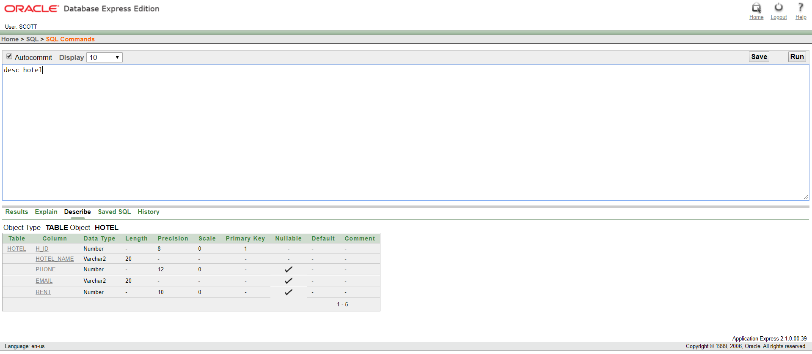

Description of HOTEL

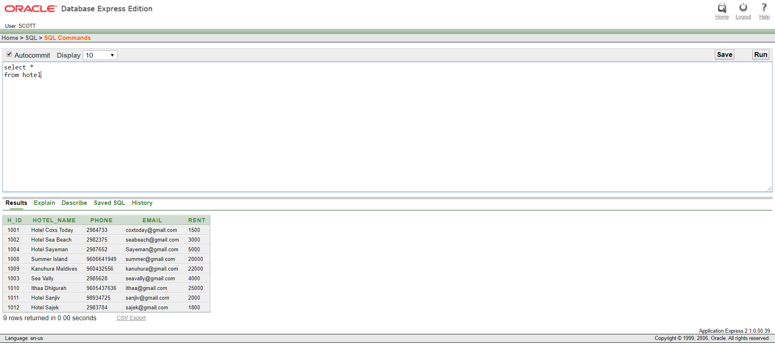

Table: HOTEL

NEW_TABLE_2:

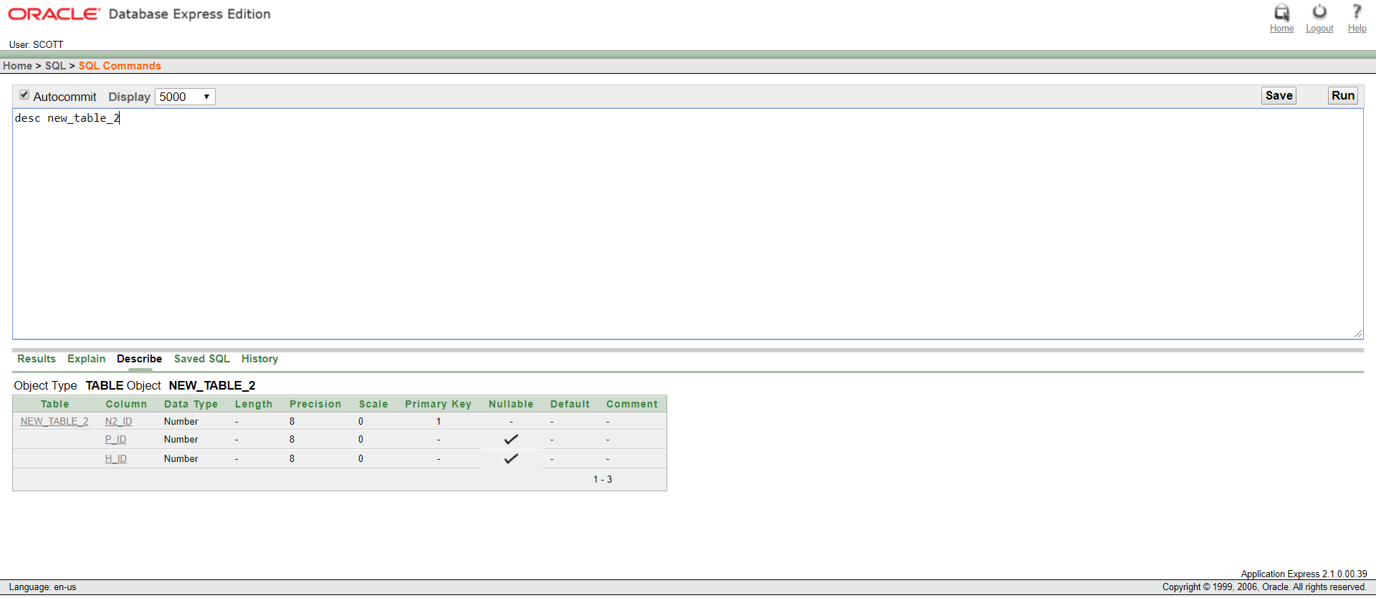

Description of NEW_TABLE_2

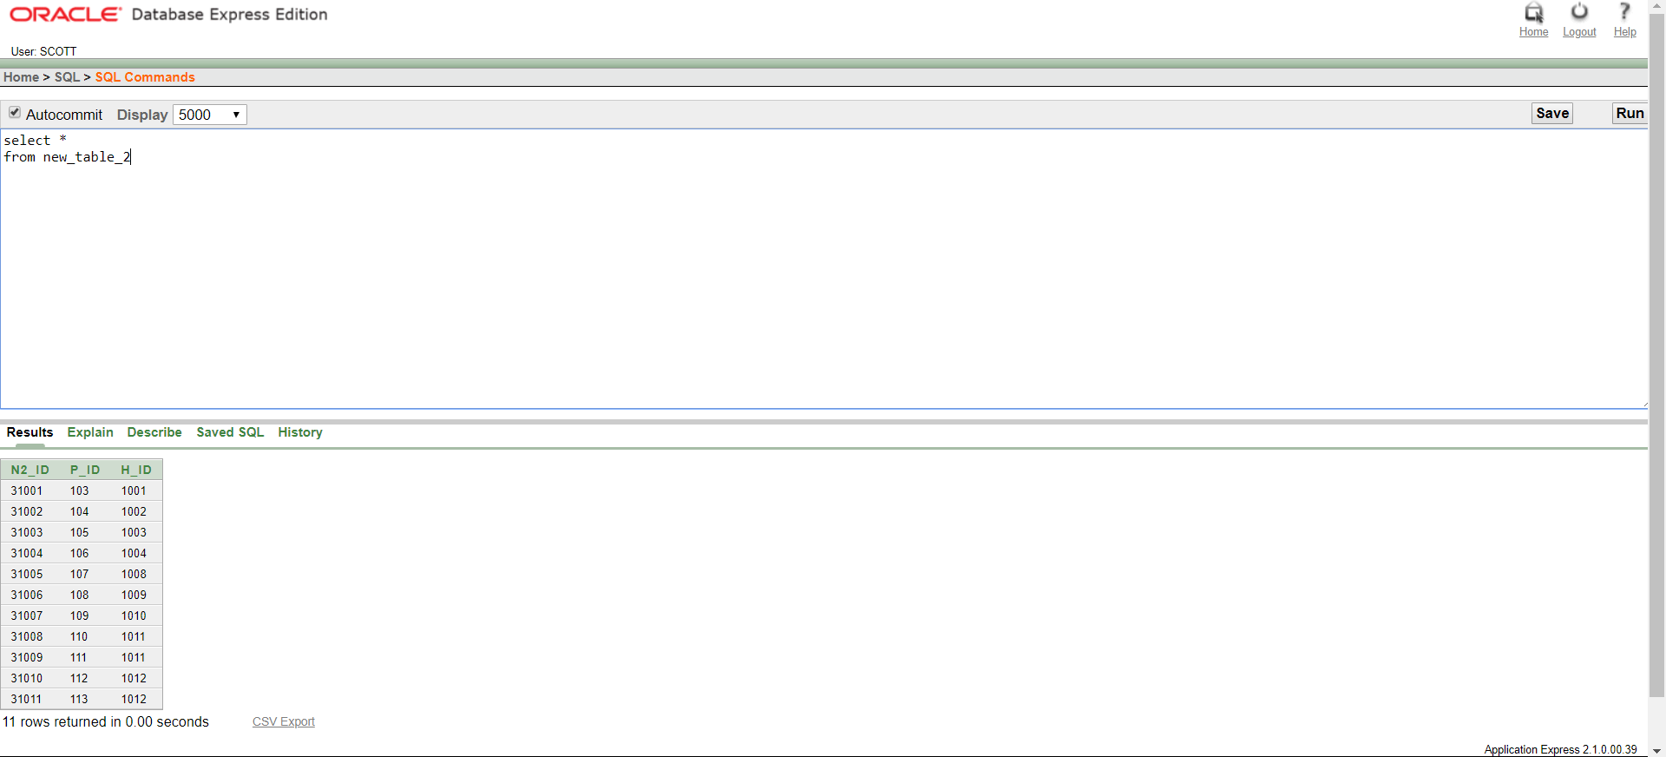

Table: NEW_TABLE 2

**Constraints**

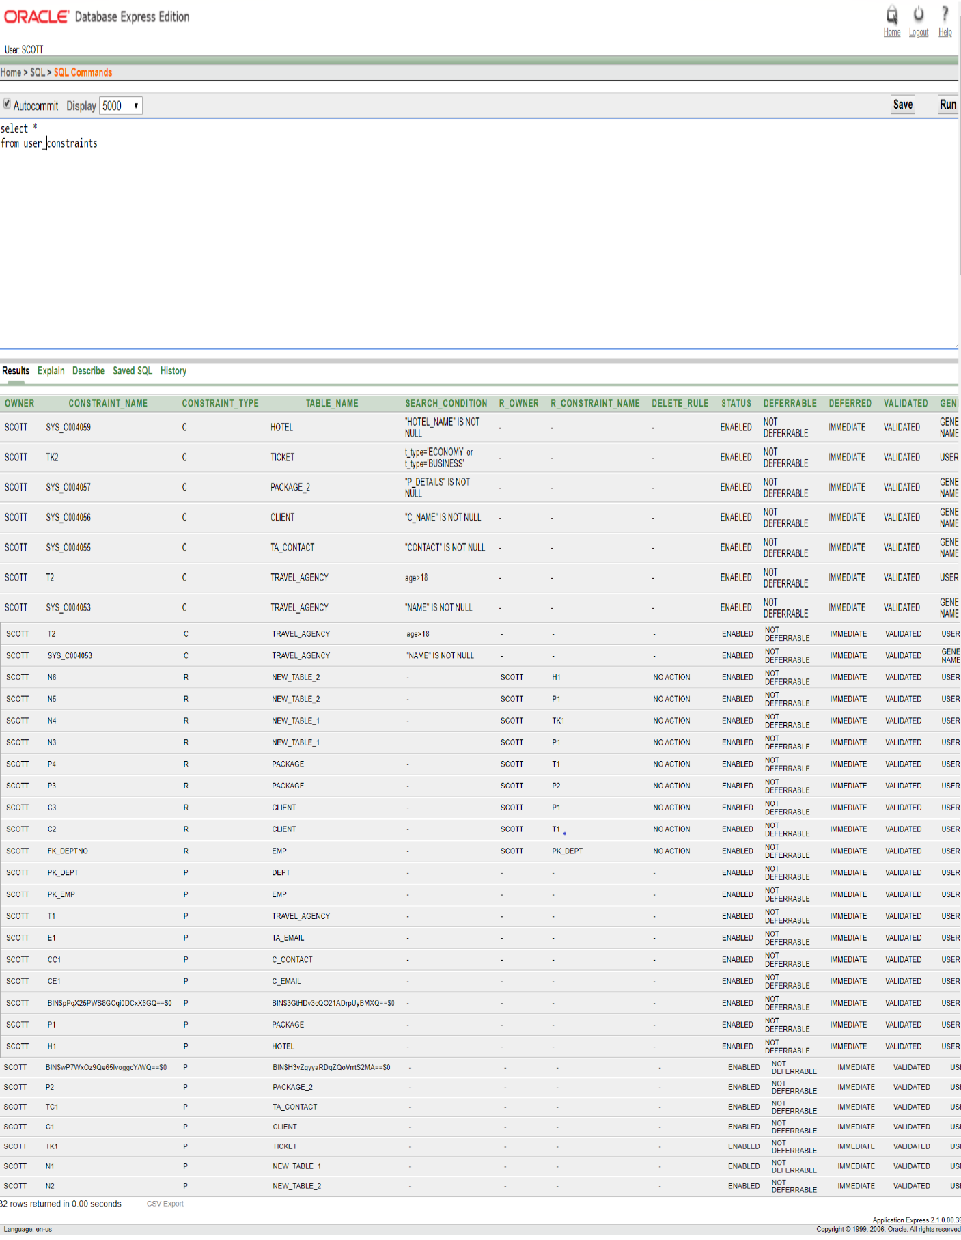

**SEQUENECE**

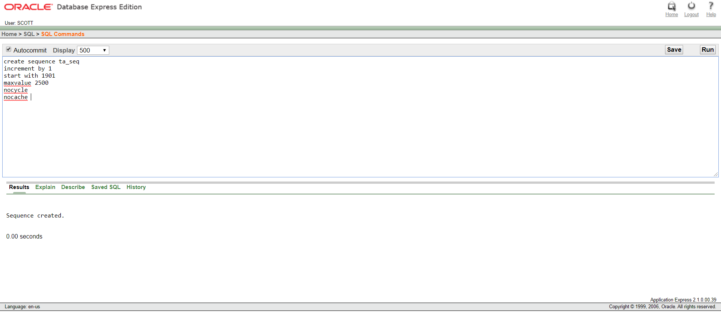

Sequence for TRAVEL_AGENCY

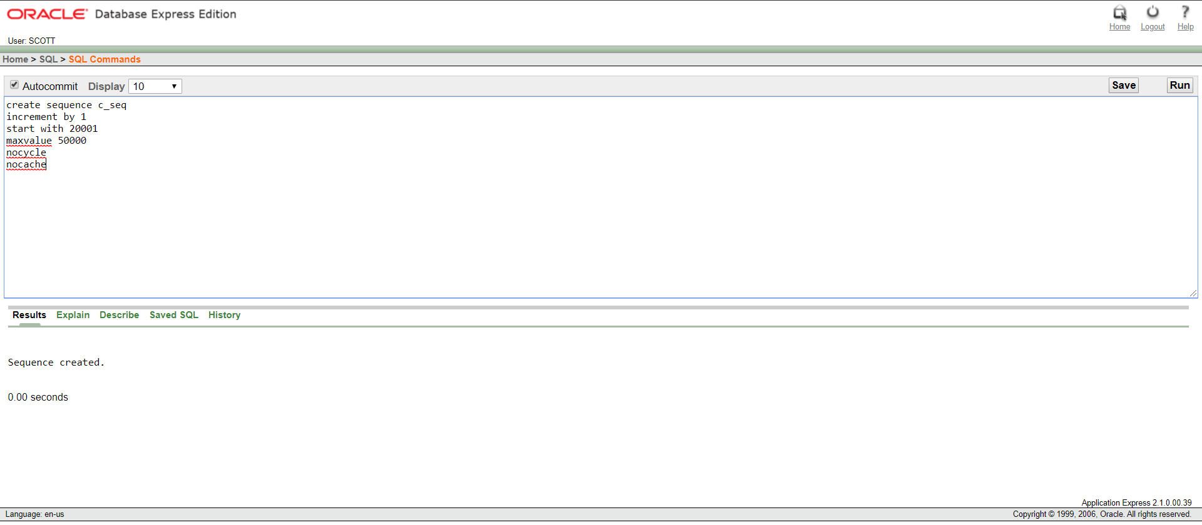

Sequence for CLIENT

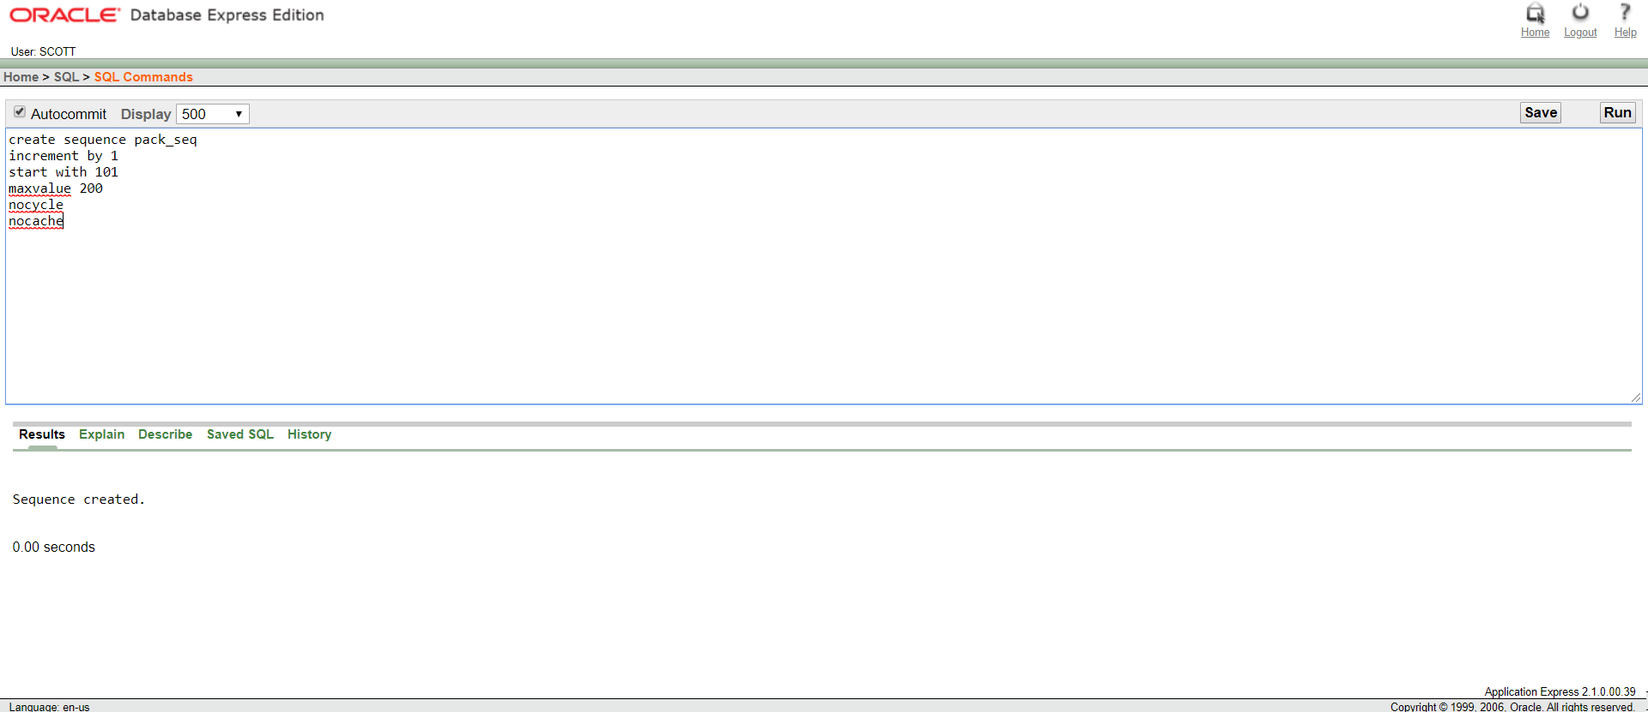

Sequence for PACKAGE

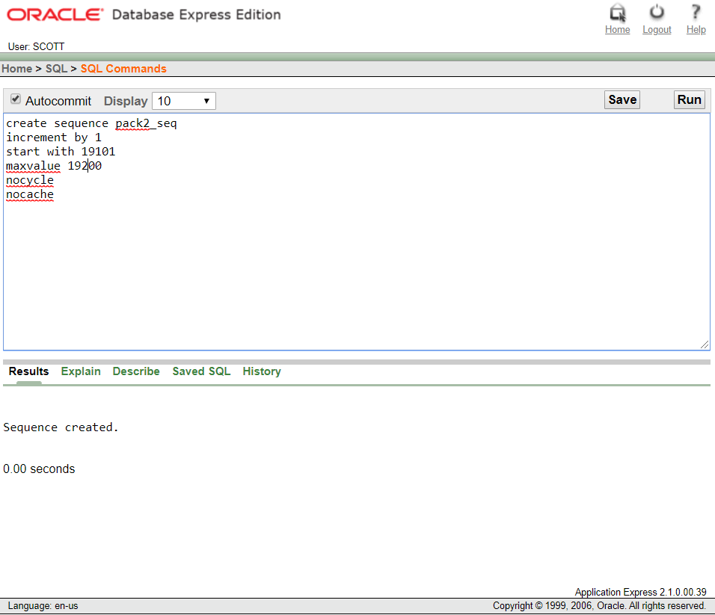

Sequence for PACKAGE_2

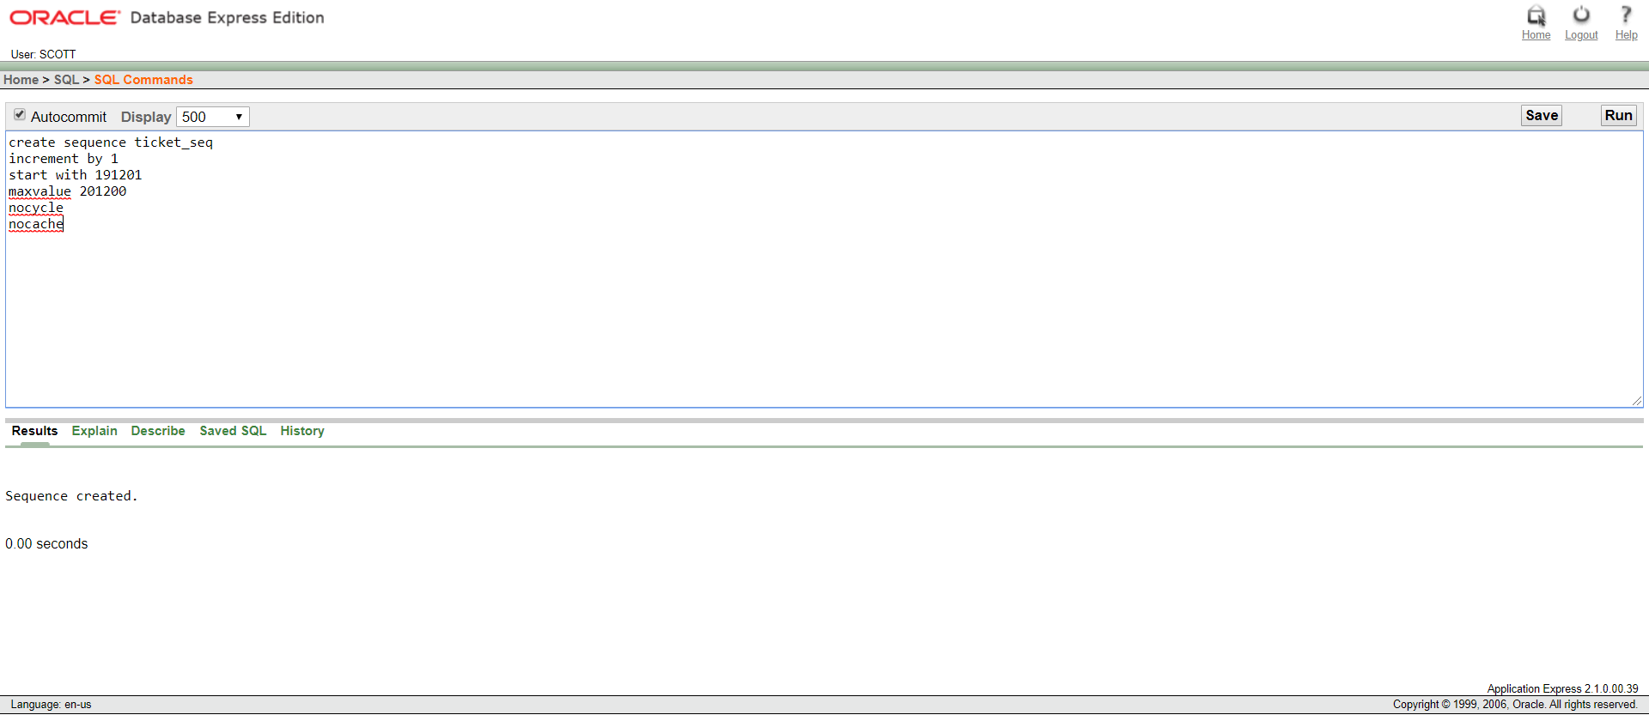

Sequence for TICKET

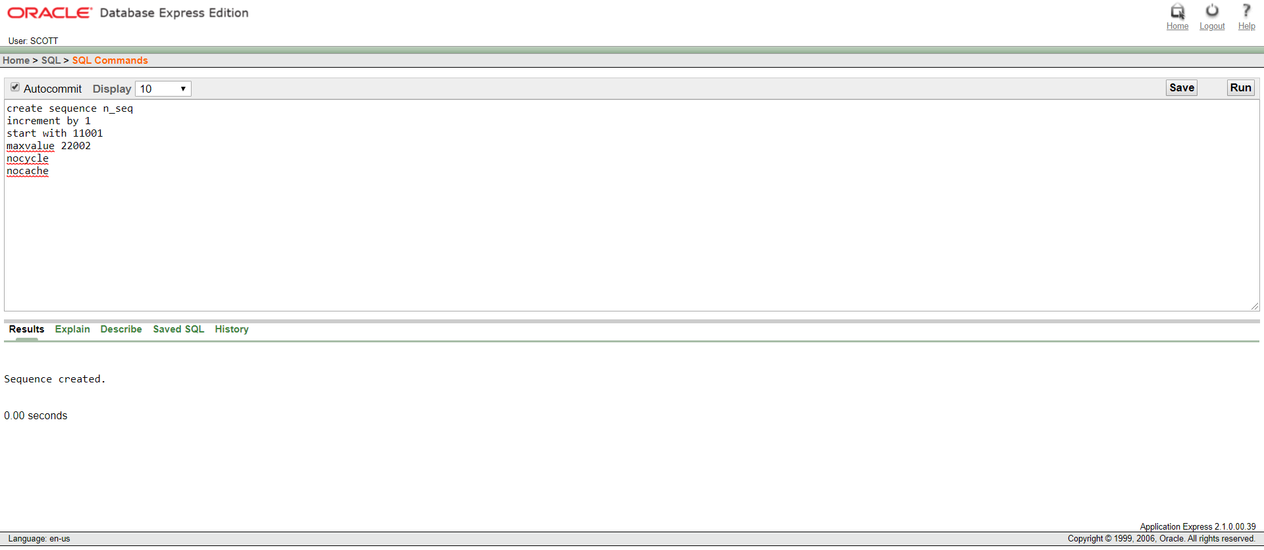

Sequence for NEW_TABLE_1

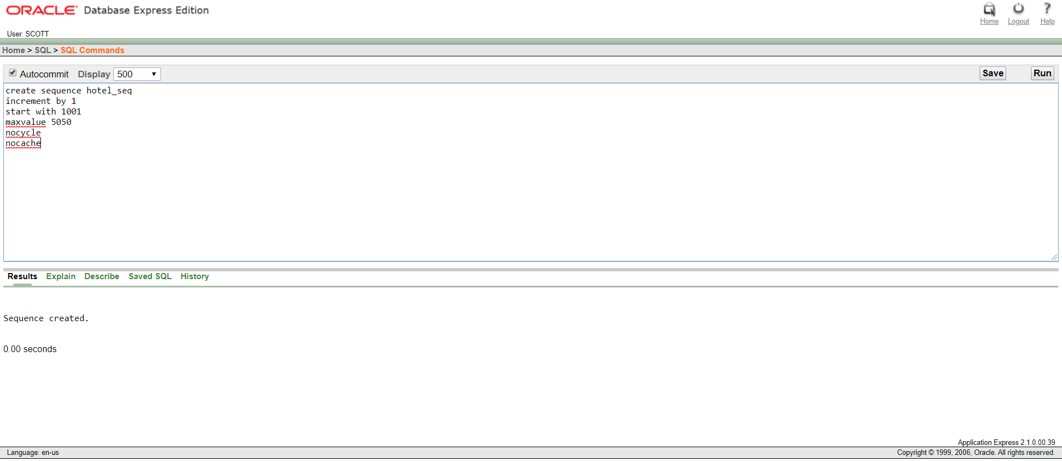

Sequence for HOTEL

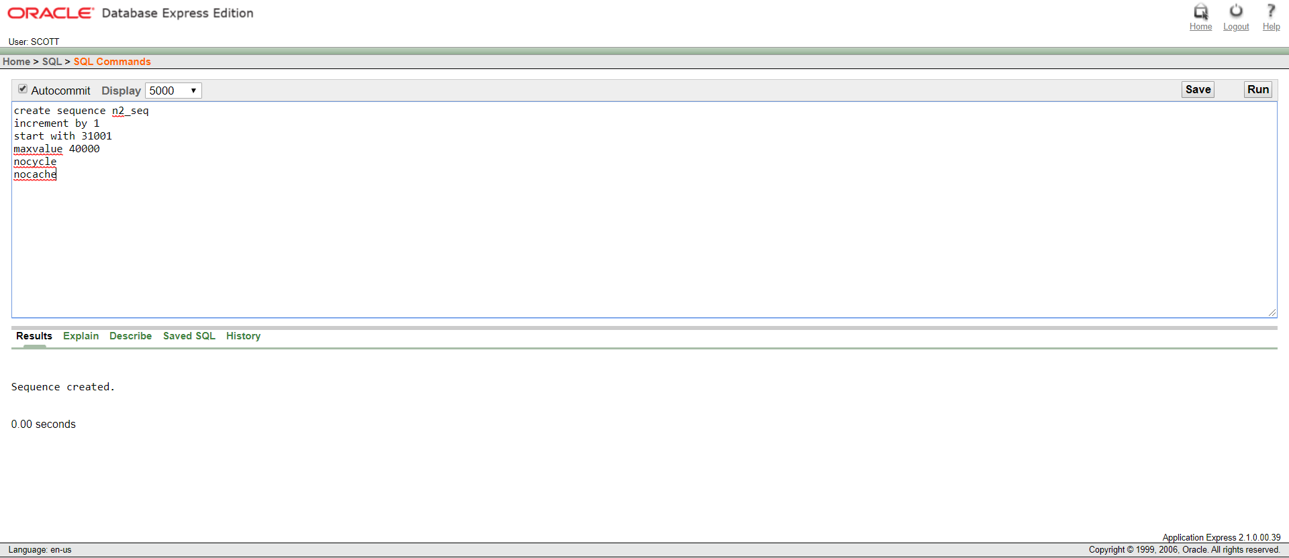

Sequence for NEW_TABLE_2

**Query Questions**

1. Find all the information of the clients whose C_id is 20003 and package type is gold.
2. Find the package name which include H_id 1010.
3. Display the package details where the package type is silver but the price is greater than 5000.
4. Create a view called B_ticket based on the company, t_type, aperture, t_price and destination where the type of ticket is business and no one is allowed to change anything but can see the table.
5. Create a sequence for hotel that the hotel id that start with 1001 and goes like 1001,1002,1003……….to 5050.
6. Alter the sequence where the sequence will go like 1001,1004,1008,1012,1016……….to 5060.Save 10 sequences.
7. Find the name of the 2nd highest salary from travel agency.
8. Display the clients name who stays in h_id 1004.
9. Display c_name, address and p_name from client and package in one table.
10. Find the all information of travel agency where client name is ‘Polok Das’.

**Relational Algebra**

1. Find all the information of the clients whose C_id is 20003 and package type is gold.

Πc_name [Ϭp_type=” gold” (Ϭpackage.P2_id=package_2.P2_id(package×package_2))

2. Find the package name which include H_id 1010.

Πp_name[ϬH_id=1010[Ϭnew_table_2.H_id=hotel.H_id(package×hotel)]

3. Display the package details where the package type is silver but the price is greater than 5000.

Πp_details[Ϭp_type=”silver” and p_price>5000(package_2)]

8. Display the clients name who stays in h_id 1004.

Πc_name[ϬH_id=1004[Ϭnew_table_2.H_id=hotel.H_id(new_table_2×hotel)]

10. Find the all information of travel agency where client name is ‘Polok Das’.

Ϭc_name=” Polok Das” (travel agency)